Use Excel to access the Real-time Data of PecStar OPC Server

Summary: Use VBA scripting language to establish an OPC Client, and access the data of the PecStar OPC Server through the OPC interface.

Key Word：Excel，PecStar OPC Server，DA，OPC.

Contents
DCOM Configuration 4
Access local PecStar Data through OPC DA in Excel 22
Access remote PecStar Data through OPC DA in Excel 26

DCOM Configuration
After you install PecStar OPC, you need to do the DCOM Configuration. Here are the steps.

- Click the Start Button>> Run, input mmc -32(on both 32bit or 64bit operating systems) and press the Enter button to open Microsoft Management Console.

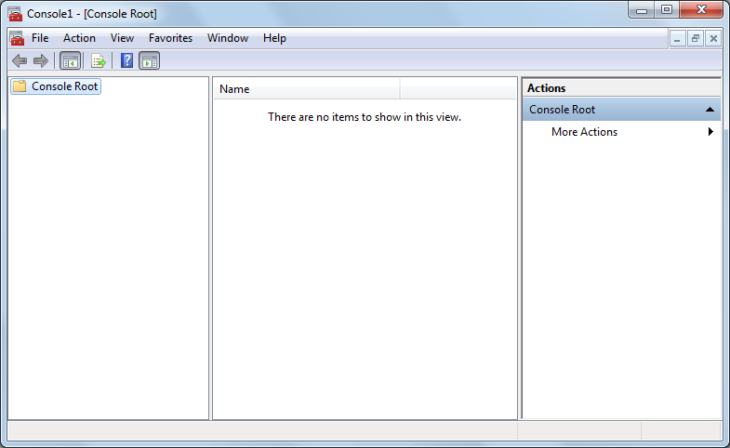

- Click File>> Add/Remove Snap-in.

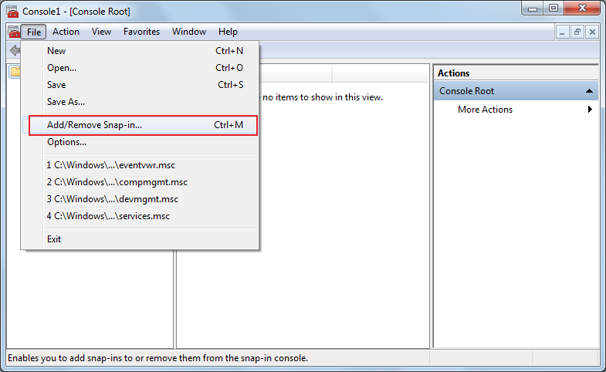

- Add the Component Services, and click OK.

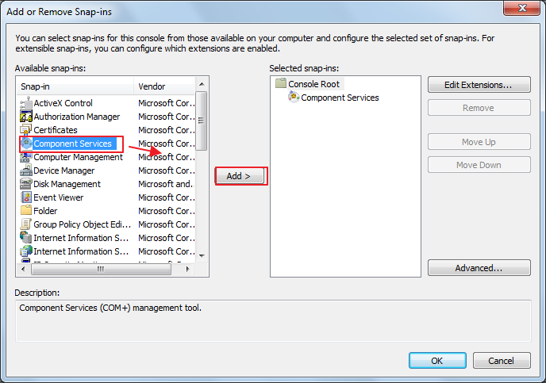

- Unfold the Component Services, right click My Computer and click Properties.

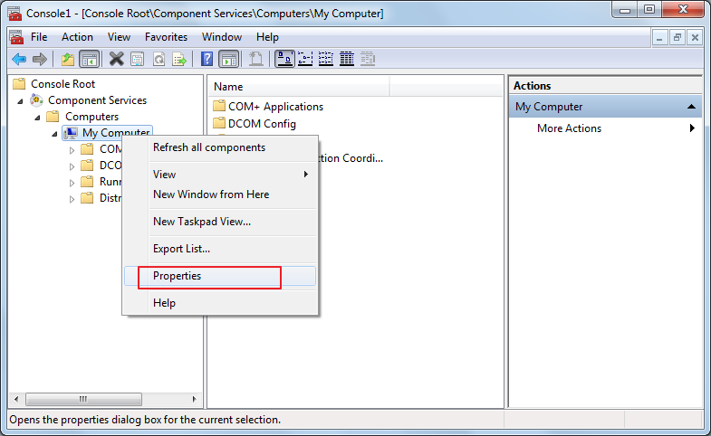

- Click COM Security>> Access Permission>> Edit Limit>> Security Limit, and set Everyone, Distributed COM Users’ permission as Allow.
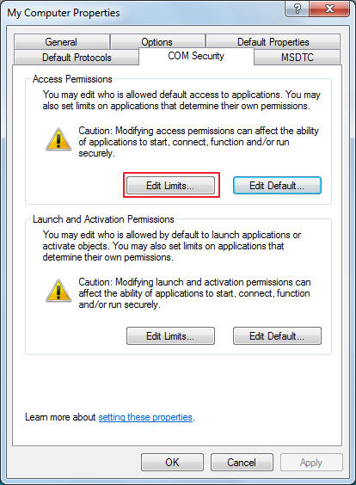

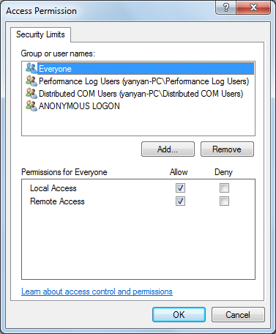

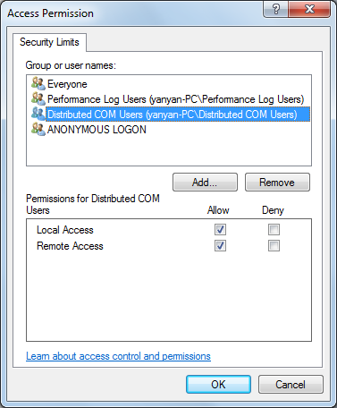

If you can’t find Everyone or Distributed COM Users in the Group or user names, you can click the Add button to open the Select Users and Groups dialog box. Then click the Advanced button.

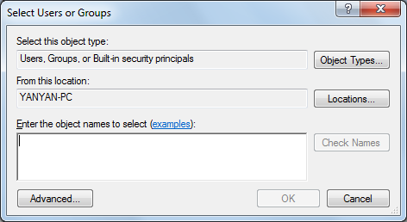

Click the Find Now button, in the Search results, select Everyone and click OK. Use the same method to add Distributed COM Users.
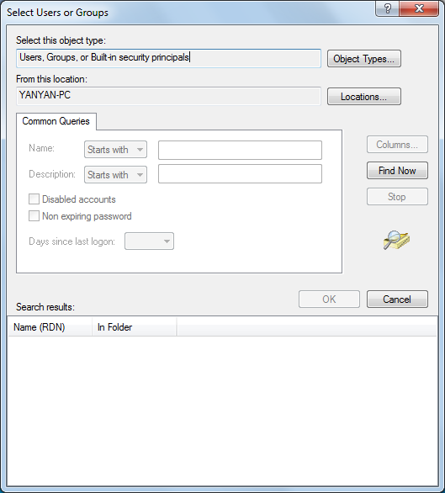
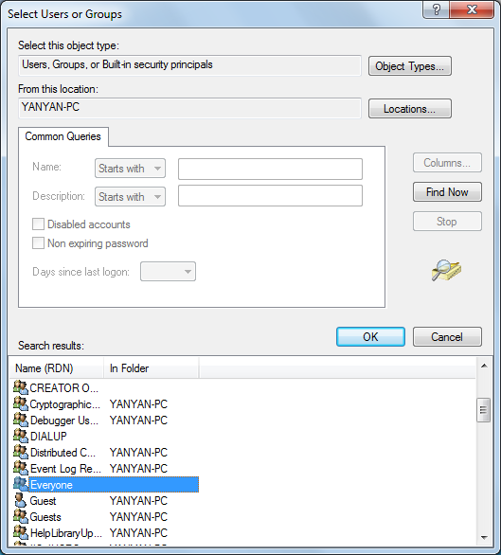

- Come back to Com Security settings. In the Launch and Activation Permissions, click Edit Limits. And set Everyone and Distributed COM Users as Allow.

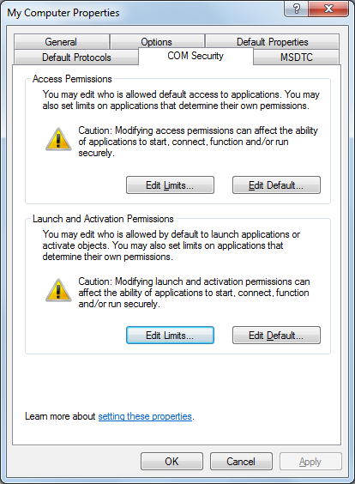

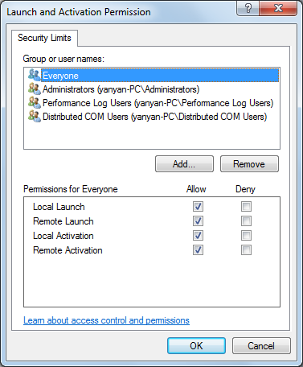
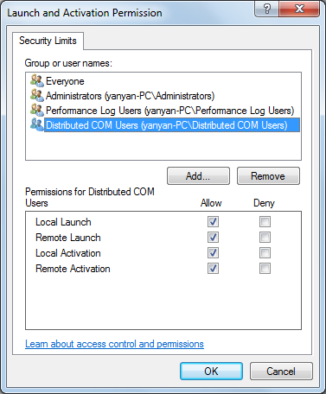

- Come back to Com Security settings. Click the Edit Default button in Access Permissions.

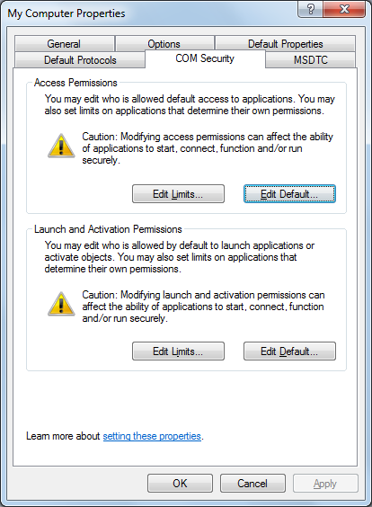

In the Access Permission dialog box, add the Distributed COM Users.

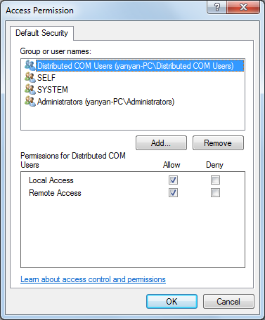

- Come back to Com Security settings. Click the Edit Default button in Launch and Activation Permissions.

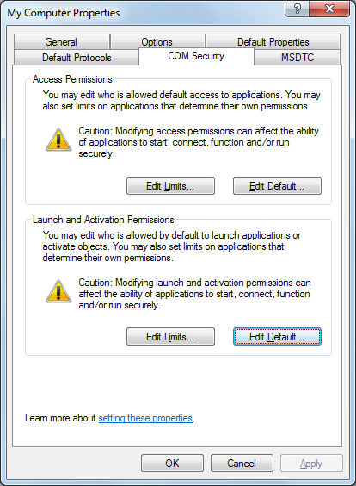

Add the Distributed COM Users.

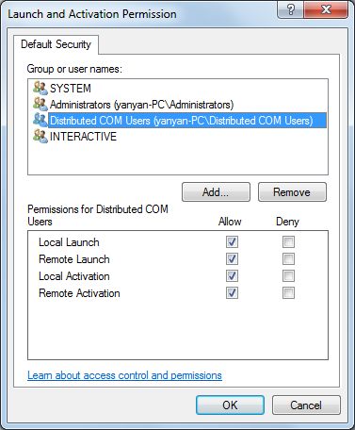

- Setup the OpcErum properties. On the right side of the list, right click OpcErum, and click Properties.

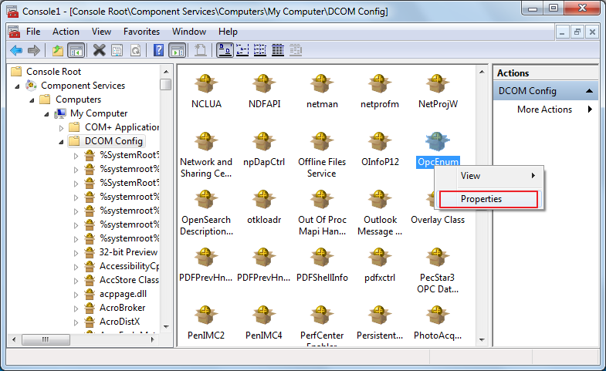

- Here is the General settings.
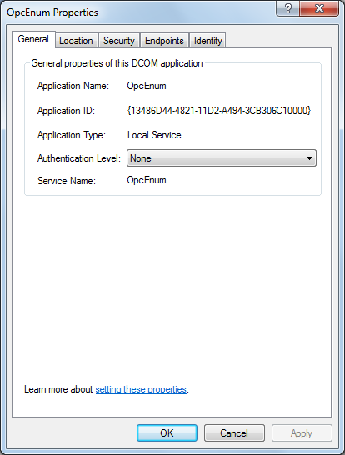

- Click Security.

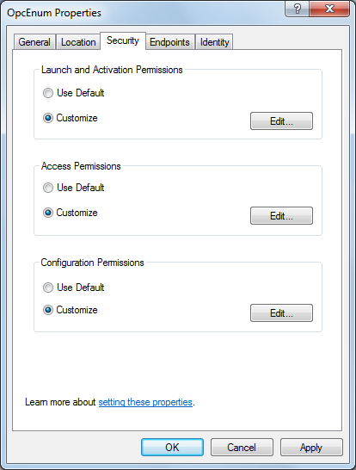

- In the Launch and Activation Permissions, click Edit and adjust the settings like this.

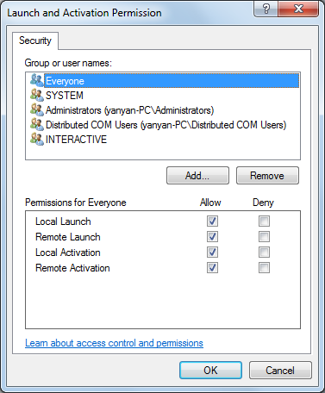
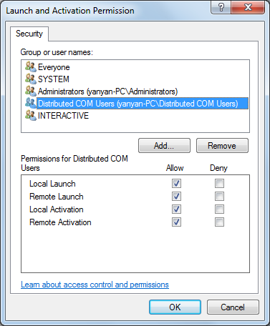

- In the Access Permissions, click Edit and adjust the settings like this.

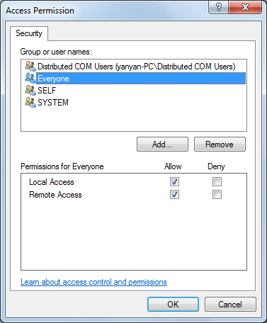

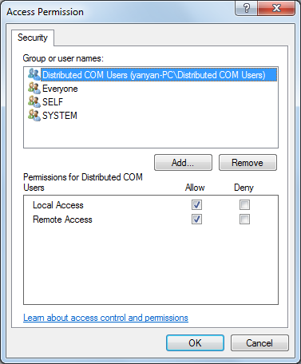

- In the Configuration Permissions, click Edit and adjust the settings like this.
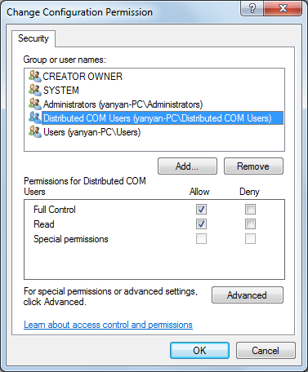

- Come back to OpcEnum Properties>> Identity. Set it as “The interactive user”, if you can’t set it as “The interactive user”, please set it as “The system account (services only)”.

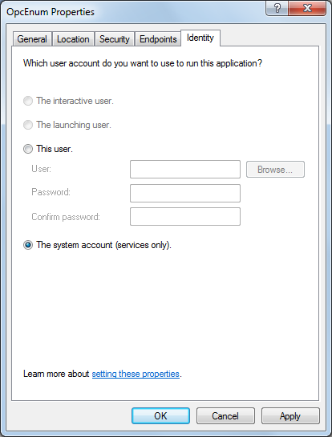

- Then please setup the PecStar3 OPC Data Access 2.0 properties.

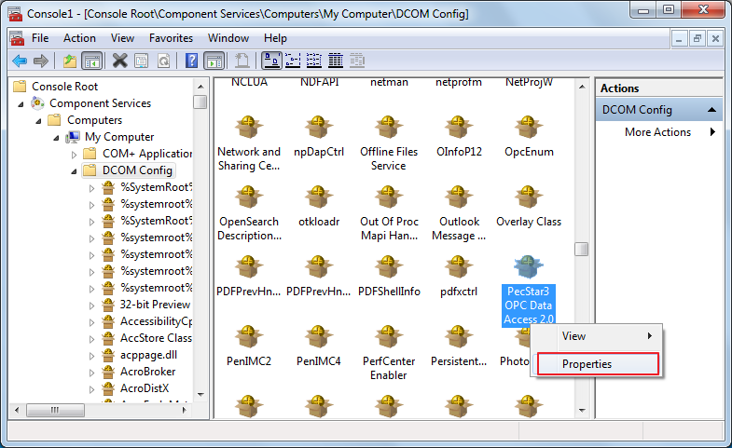

- Here is the General setting.
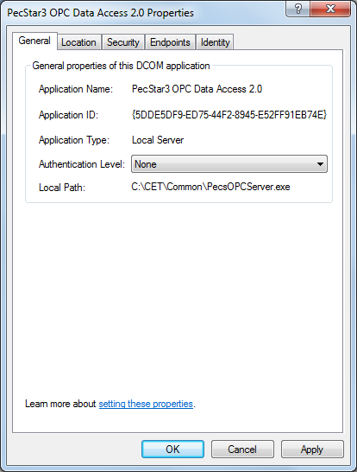

- Adjust the security settings like this.
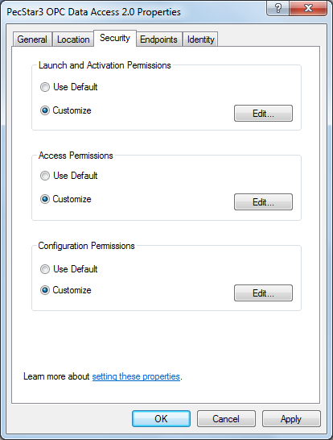

- Click the Edit button in Launch and Activation Permissions, adjust it like this.

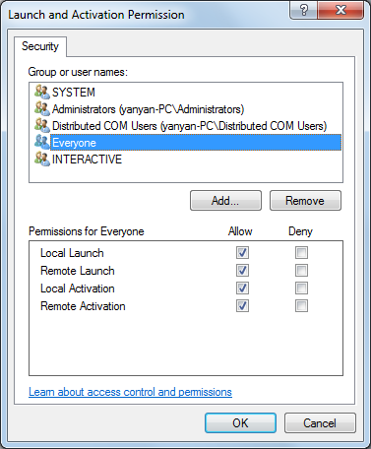
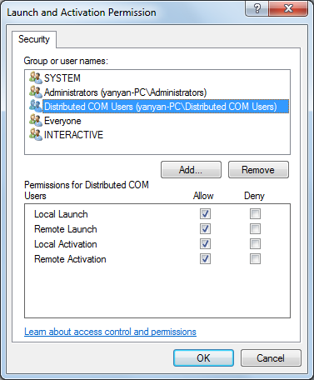

- Click the Edit button in Access Permissions, adjust it like this.

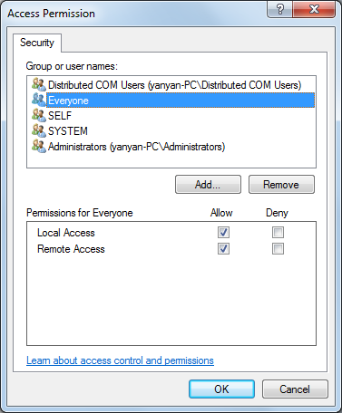
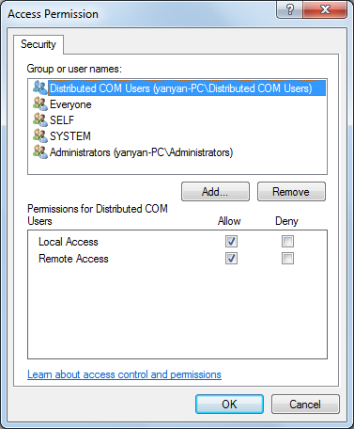

- Click the Edit button in Configuration Permissions, adjust it like this.

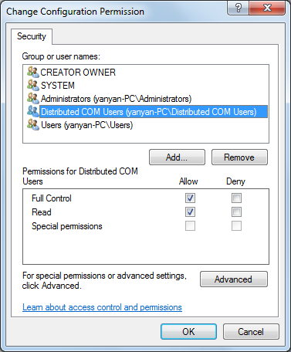

- Come back to PecStar3 OPC Data Access 2.0 properties, in the Identity, set it as
“The interactive user”. If you can’t set it as “The interactive user”, please set it as “The system account (services only).
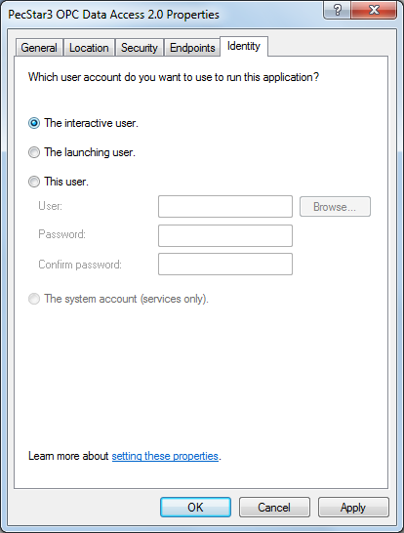

Access local PecStar Data through OPC DA in Excel
The attached file: PecStar-OPC-Excel.xls uses VBA scripting language to establish an OPC client in Microsoft Excel, and access the PecStar Data through the OPC interface.

To use it, please do the following steps.

  - To show the Developer tab in the Ribbon, click the Office Button>> Excel Options>> Popular>> Show Developer tab in the Ribbon. And click OK.

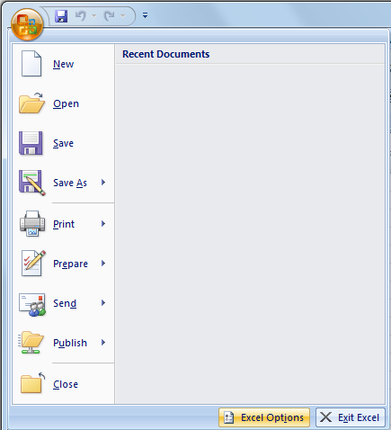

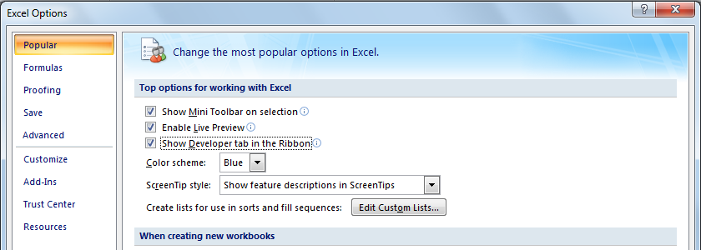

  - You need to adjust the Macros Security settings. Click Developer>> Macro
Security. Select “Enable all macros (not recommended; potentially dangerous code can run)” and select “Trust access to the VBA project object model”. Then exit Excel and restart it.

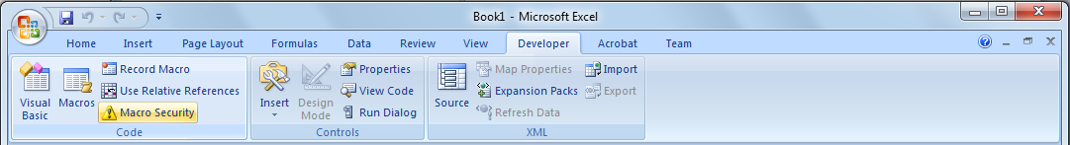

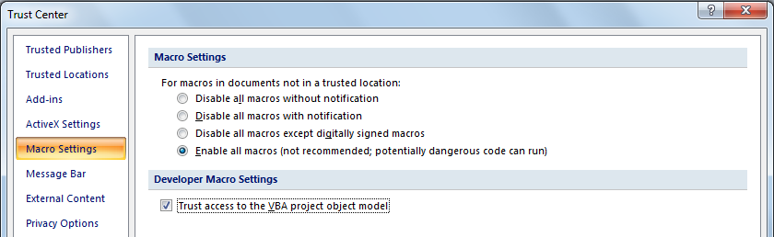

  - Open the PecStar-OPC-Excel.xls file. In the C2 grid, input your Computer Name. And from C3 to C8, input the names of the parameters. Then click Developer>> Macros, in the pop up window, click Run, and the corresponding Real-time values will be read and shown in the grids.

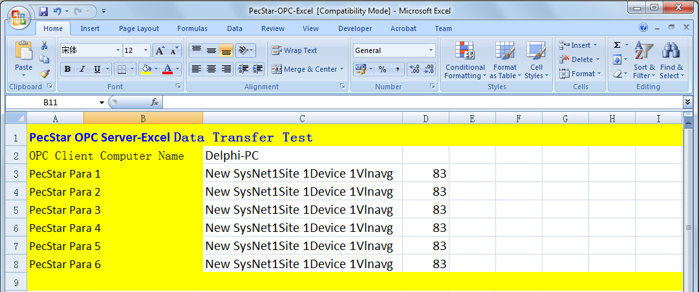

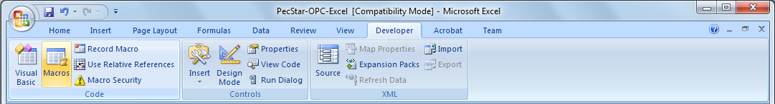

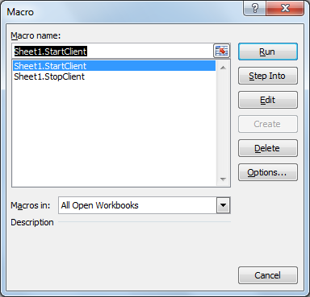

1.4 If you want to use Microsoft Excel as the OPC Client, please follow the below configuration instructions.

Create an interface in Excel. Click Develop>> Visual Basic, and click Tools>> References.

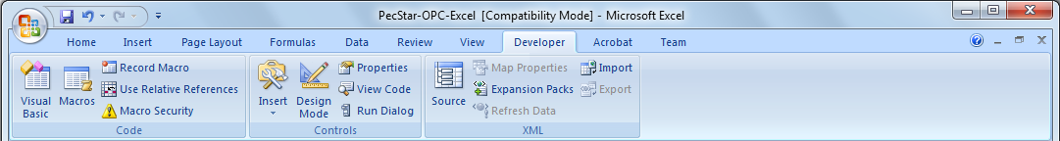

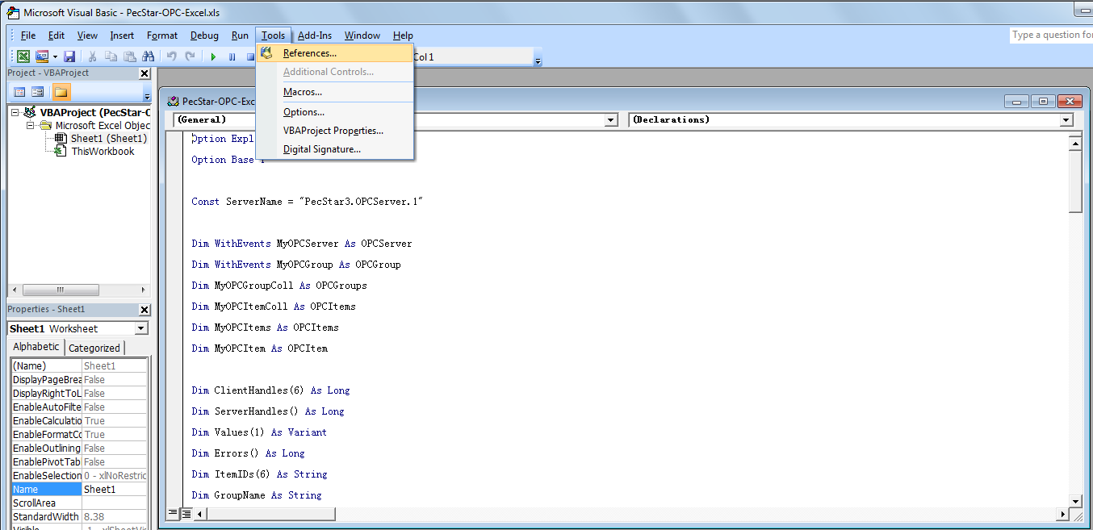

As shown in the picture, you should select all the OPC References so that Visual Basic can recognize the OPC Objects. Then click OK.

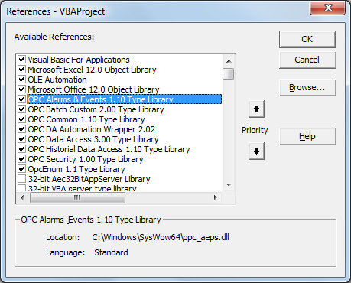

Then, setup the parameters of the PecStar OPC Server that will be read. As shown in the picture, connect C2~C8 with the PecStar OPC Server Name and parameter 1~6.

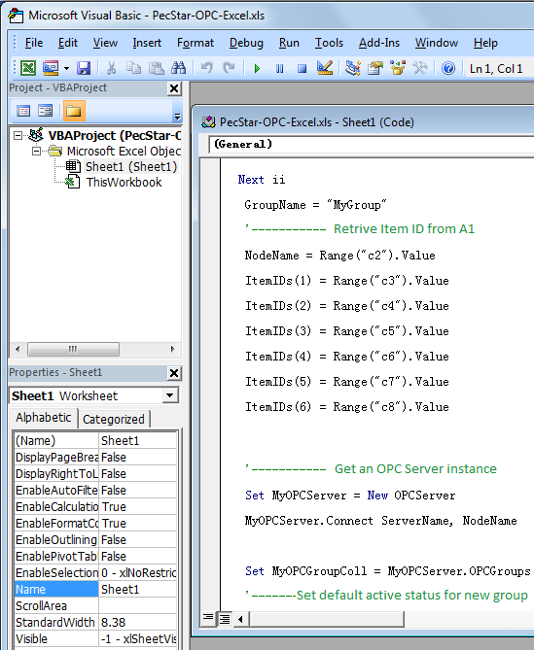

Then, setup the grids that the data will be transferred to. As shown in the picture, the values of parameter 1~6 will be transferred to the D3~D8 grids.

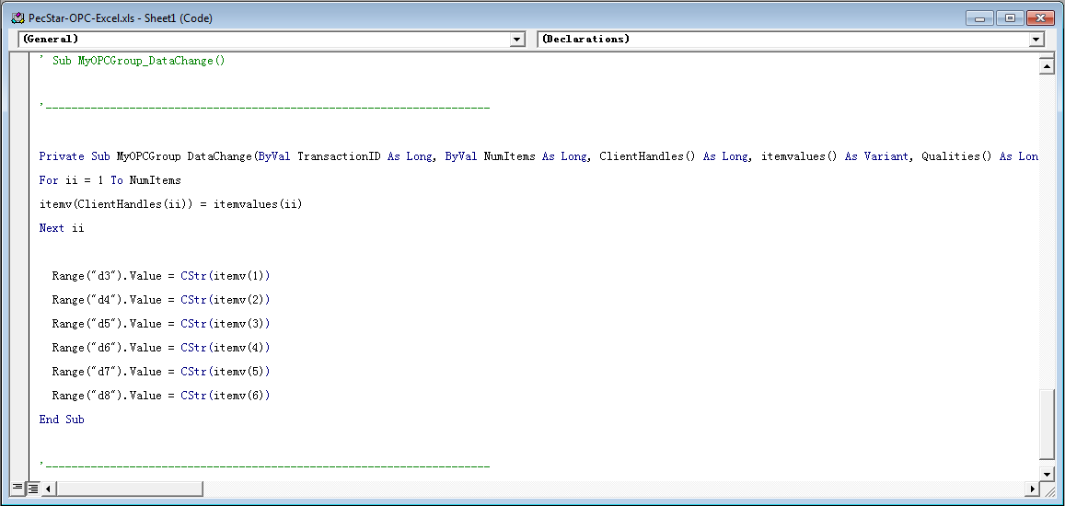

And then, in the C2~C8 grids of the Excel file, you should enter the Computer Name of the PecStar OPC Server, and the names of the parameter 1~6, then save the file. When you execute the Macros, the OPC Server data will be displayed in the C3~C8 grids. When the values change, the data will be automatically sent.

Access remote PecStar Data through OPC DA in Excel
If you want to access a remote PecStar OPC Server through DCOM on an OPC client, you need to input the PecStar OPC Server’s Computer Name in the C2 grid.

OPC client can run on any computer in the network, but the computer must configure its DCOM access permission. A simple way to this is to use the same user name and password to login in on the PecStar OPC Server and the OPC client.

